BLOCKCHAIN BASED IOV INTEGRATED MODEL FOR SECURE REAL-TIME ORGAN TRANSPORT AND ANTI-TRAFFICKING MEASURE

Submitted in partial fulfillment of the
Requirement for the Master’s degree
in
Information Technology
By
SHARME K
24/PCSA/121
November 2025 - April 2026

Stella Maris College (Autonomous)
17, Cathedral Road,
Chennai-600086.

STELLA MARIS COLLEGE (Autonomous)
17, Cathedral Road,
Chennai-600086.
Master of Science (Information Technology)
(Affiliated to University of Madras)

BONAFIDE CERTIFICATE
This is to certify that this is a bonafide record of the project done by
SHARME K
On
BLOCKCHAIN BASED IOV INTEGRATED MODEL FOR SECURE REAL-TIME ORGAN TRANSPORT AND ANTI-TRAFFICKING MEASURE
At
Stella Maris College (Autonomous)
November 2025- April 2026
This project was done by her in partial fulfillment of the Requirements for the Master’s degree Information Technology

Head of Department Internal Guide External Examine
ACKNOWLEDGEMENT
First of all, I am deeply indebted to God the Almighty for being the source of my strength, guide, confidence and inspiration.
With deep gratitude I sincerely thank my institution Stella Maris College that has given me the opportunity and confidence to complete my research project in this institution.
I express my deep sense of gratitude to my principal Dr. Sr. Stella Mary fmm Stella Maris College, for the facilities provided by her in carrying out this work.
I would also like to thank my Head of the Department, Ms. Blessy Boaz M.Sc.., M.Phil., NET and faculties of the Department of Computer Science for their constant support throughout this project.
I would like to sincerely thank my project guide Dr. Swetha Margaret T A MCA., M.Phil., Ph.D. for her constant support and encouragement without which I wouldn’t have completed this project successfully.
I would like to sincerely thank my project Coordinate Dr. Renuka Devi D M.C.A. M. Phil. for her constant support and encouragement to complete this project successfully.
I would like to sincerely thank my project Coordinate Ms. Geethanjali I M.Sc., NET, for her constant support and encouragement to complete this project successfully.

PLACE: Chennai SHARME K
DATE:

ABSTRACT
Organ trafficking is an acute and international problem that can be considered as a serious threat to ethical medical activities, patient welfare, and human rights. To avoid illegal diversion, tampering, and unauthorized access of organs, it is necessary to ensure safe, timely, and open transportation that should be performed between the donor and recipient. The conventional organ-moving networks are based on centralized monitoring structures that are largely susceptible to manipulation, hold-ups, communications, and point of failure. Such constraints have potential of compromising the process of delivering the organs and sometimes even endangering lives of patients. To overcome them, the present project suggests implementing a Secure Organ Transport Monitoring System encompassing the implementation of advanced technologies, including blockchain, real-time tracking, and smart alert systems. The system keeps detailed records of donor and patient data, organ donation, and transport status of donor organs in a safe blockchain registry, which guarantee the immutability, transparency, and responsibility of data. The blockchain technology eliminates any unauthorized modifications to the transport history and creates an audit trail that is verifiable by all events of organ delivery. The suggested system will help to eliminate the threats of organ trafficking, increase the efficiency of operations, and enhance the levels of trust between medical institutions by integrating blockchain and real-time transport tracking and warning. Besides, the system also offers a single platform to healthcare administrators to handle data on donors and patients, track organ deliveries, and produce audit reports. These mechanisms make the project reliable in ensuring that organs arrive at their intended recipients in a timely and safe manner enhancing patient outcomes and promoting ethical medical practices.

Keywords: Organ Transport, Blockchain, Real-Time Tracking, Smart Alerts, Healthcare Security, Transport Monitoring, Data Integrity.

TABLE OF CONTENTS

S.NO | CHAPTER | PAGE NO
1 | CHAPTER 1: INTRODUCTION
2 | CHAPTER 2: REVIEW OF PAST WORK AND PROBLEM FORMULATION
3 | CHAPTER 3: METHODOLOGY
4 | CHAPTER 4 : RESULTS AND DISCUSSION / ANALYSIS.
5 | CHAPTER 5: CONCLUSION
6 | CHAPTER 6: APPEDNIX
7 | REFERENCES

LIST OF FIGRUES
S.NO | TITLE | PAGE.NO
1 | Architecture Diagram
2 | System Working flow
3 | Login Interface of the Administrator
4 | Interface of Donor Registration.
5 | Interface of a patient request.
6 | Organ Allocation Interface.
7 | Organ Transport Interface.
8 | Organ Delivery Confirmation Interface
9 | Organ Delivery Confirmation Interface
10 | SQL Server Database

CHAPTER 1: INTRODUCTION
Organ transplant is now among the greatest discoveries in the contemporary medical field since it has provided a life-saving solution to patients with organ failure. Nevertheless, the transportation of the organs between the donor hospitals and recipient hospitals is very sensitive and time-restrictive. In case of any delay, inadequate coordination, and security concern in the transportation process, damage of the organ and wastage of precious time in cases of emergency may occur. As such, the semblance of safe, open, and effective organ transport monitoring is so crucial within the healthcare logistics [1][2].
Although the healthcare infrastructure has been improved technologically, the traditional organ transport monitoring systems do have a number of challenges. Most of the systems in use are based on central databases and manual tracking systems, which can be tampered with, hacked or lack in consistency. Moreover, the absence of clear tracking systems allows the authorities to understand whether the organ is delivered safely and via the proper route. These restrictions can cause delays, misunderstanding and misuse in the transportation process [3][4].
New opportunities are offered by the latest progress in the technologies of distributed computing that can help to enhance the reliability of the medical logistics systems. Blockchain has become an influential technology in the security and inability to be tampered with records. A blockchain is a digital registry that is decentralized and in which information is stored in cryptographically connected blocks. Data integrity and transparency are ensured by the existence of extremely hard to alter or delete information in the blockchain after it is saved in the blockchain. This characteristic renders blockchain especially helpful in documenting crucial occasions in the organ transportation systems like request authorizations, transport triggering, and delivery authorization [5][6].
The other technological breakthrough is edge computing which will allow a quicker validation and decision-making process by processing information towards the source of the data. In contrast to having all the operational data sent to a centralized server, edge-based systems are capable of validating events at the edges and sending alerts when something out of the ordinary happens. This technique minimizes processing time and enables faster response when there is an emergency medical transportation situation [7][8].
The use of blockchain-based secure record keeping along with edge-level validation will enable the contemporary transport monitoring systems to boost the transparency and dependability of operations. All phases of the organ transport process can be captured at a safe place, without compromising the information to the stakeholders including hospitals, administrators and healthcare authorities with reliable and verifiable information [9][10].
The system suggested in the given project is aimed at creating a safe organ transport monitoring system, which would enable patients to post their organ requests and administrators to check and accept those requests. After giving an approving response, the system allows the route tracking of a transport vehicle between the donor and recipient hospital. The site also has a database where the patient details, request [2] status and the confirmation of the delivery are logged. The system updates the delivery status in the database when the transport process is received at the destination to make sure that the records are accurate and transparent.
The proposed system will enhance the visibility and quality of the organ transportation process by incorporating the safe data record system, visualization of the routes, and the administration workflow that is controlled. Such a system may help healthcare [5][6] institutions to ensure the effective organization of the critical organ transportation operation and retain the trust and responsibility towards the process, in general.
Organ transplantation has been saving millions of lives across the globe. Nevertheless, the organ transport is subjected to serious difficulties:
• Illegal diversion of organs
• Manipulation of the centralized tracking systems.
• Lack of prompt reaction in an emergency.
• Issue with check-up of donor-patient coordination.
The development of blockchain technology, Internet of Things devices, as well as edge computing provides an opportunity to improve security and transparency. Blockchain gives an opportunity to maintain the record of events that cannot be changed, and IoT sensors make it possible to monitor the conditions of the transport in real-time. [9] In the event of an unauthorized access or the route deviation, the edge-based alert system can alert the stakeholders on the spot. [7] [8].Secure transportation of organs is valuable in that it will save the lives of many people who need organ transplantation.
Organ transplant is lifesaving medical practice, and this involves an urgent and safe transportation of organs across hospitals. Transportation process must be done with a lot of care in order to ensure that the organ may reach to the recipient at the appropriate time within the required condition of the medical status. Any failure or lack of tracking of the process of transportation may cause serious threats to the life of the patient.
A monitored system is an important use of a secure system to maintain the organs during transportation, which is safe and efficient. By using electronic monitoring, the hospitals will be in a position to track the movement of the transport vehicle and to ensure that the organ reaches the correct destination. This increases transparency during the organ transplant and reduces the possibility of organ misplacement or blackmail.
The proposed system will be used to increase the safety and monitoring of the organ transportation by maintaining the sufficient records and offering the methodized system of the donor and patient information.
Problems of Organ Transport Systems.
Transplantation is an organ that is essential in the transplantation process. Proper coordination between the hospitals, medical teams and the transportation services is one of the major difficulties in the organ transport systems. In the absence of the systematic monitoring system, the movement of the organ during the transportation becomes hard to trace. Organ transplant patients are at high risk due to traffic jams in transportation or communication failure between hospitals.
The other problem is the inability to be transparent in the transportation process. In most instances, hospitals rely on manual modes of communication to ascertain the status of delivery of the organs. Such a strategy can cause information sharing errors or delays. Thus, it is necessary to introduce a digital monitoring system to enhance the level of transparency and efficiency in transportation of organs.
The proposed area of the Secure Organ Transport Monitoring System is the introduction of a systemic platform in the management of information about donors, patient demand, and monitoring of transportation. The system is to assist the hospitals to organize the organ transplantation activities more efficiently. The suggested system is aimed at keeping precise records of donor and patient information and proper tracking of the transportation procedure. The system enables the administrators to store and retrieve information within a short time through a centralized database. This enhances the co-ordination between the hospitals and contributes to the effectiveness of delivery of the organs to the intended recipients

CHAPTER 2
REVIEW OF PAST WORK AND PROBLEM FORMULATION
2.1 This paper provides an overview of Organ Transportation Systems.
Organ transplantation is a very vital healthcare procedure and relies on the quality and punctuality of the transportation of organs between the hospital where the donors are located and the hospital where the recipient is. The logistics division should be tightly coordinated with the healthcare authorities and the hospitals in the transportation process. The traditional systems are primarily centralized in terms of data management and manual coordination. Even though these systems have a positive impact on the management of organ allocation, they are not always transparent and were not designed to monitor in real-time [1].
Most healthcare institutions have organ transportation records that are managed in central databases. Nevertheless, a centralized system can be limited in a number of ways including unauthorized access of data, manipulation of data, and a lack of the ability to track. Even the failure to deliver on time or even a breakdown of communication can influence the success rate of transplantation in the emergency medical logistics. Thus, enhancement of reliability and monitoring of organ transportation systems has emerged as a significant field of research [2].
Scientists have examined some digital remedies to enhance healthcare logistics. Distributed data management technology, secure digital records technology, and real-time tracking systems have been proposed to enhance supervision and coordination among healthcare stakeholders [3].
2.2 Current Tracking and Monitoring Solutions.
Various research works have also been done on the development of monitoring systems that trace the movement of medical supplies and organs as they are transported. Such systems are usually based on digital tracking platforms which enable the healthcare administrators to keep track of the location and status of the transport process.
Tracking systems can also have route tracking, positioning, and alert services whereby the stakeholders are alerted in the event of delay. Nevertheless, most of the current systems continue to use centralized infrastructure where all data gets stored and controlled by one person. These architectures can be prone to the corruption of data or other unauthorized alterations [4].
To solve these problems, scholars have come up with distributed monitoring platforms that enhance reliability of medical transportation. Such systems make sure that any information tied to transport requests, approvals and delivery confirmations are kept safely and can be validated by various stakeholders participating in the process [5].
2.3 Medical Logistics with the help of Blockchain.
The blockchain technology has attracted a lot of attention to secure data management in different sectors such as healthcare. In blockchain, the system is a decentralized ledger employing cryptographically linked block transactions to record transactions. When the information is stored in a blockchain network, it is virtually impossible to change or delete the information, which provides data transparency and integrity [6].
Blockchain can also be utilized in healthcare logistics to help record significant events during requesting an organ, administrative approval, starting the transportation process, and receiving the final confirmation of delivery. Every event is registered as a transaction in the distributed ledger and therefore, it becomes simpler to verify authenticity of records.
Blockchain has been demonstrated to enhance trust and transparency in the supply chain systems in various studies. Blockchain facilitates the provision of tamper-resistant records that mean that all the stakeholders will access consistent and reliable information every part of the transportation process [7].
2.4 Edge-Based validation and its role in monitoring systems.
Edge-based data processing is another crucial development in the current computing world. Edge computing enables processing of data to occur nearer to the generation of the information compared to using entirely centralized cloud servers.
Edge-level validation can be used in monitoring systems to identify abnormal conditions very fast. As an illustration, when the transportation path becomes different due to unforeseen circumstances, or when some abnormality is identified in the process of transportation, the system will be able to provide notifications instantly. This minimizes the response time and makes critical healthcare operations quicker in decision making [8].
The use of edge-based validation also lowers the dependence of the network since it is possible to check some of the operations locally and then add them to the main system database. This enhances efficiency and reliability of the system throughout real time performance.
2.5 Shortcomings of Current Systems.
Although new technological advances have been made in the last few years, there are still a number of shortcomings in the existing monitoring system of the transportation of organs.
First, most systems are still based on centralised infrastructure, which can be subject to data manipulation and point of failures. Second, traditional ways of monitoring might not be transparent as it is not easy to validate the authenticity of records of transport by the stakeholders. Third, lack of automated alert systems can slow down response to case of emergency [9].
The other problem is that there are no integrated systems that incorporate safe record management with real-time monitoring features. Most of the systems are only concerned with tracking or data storage but end to end transparency throughout the process of transportation is not implemented.
2.6 Problem Formulation
Judging by the drawbacks that have been outlined in current systems, it would be necessary to have a secure and transparent platform monitoring organ transportation. The system is supposed to provide a way in which the requests on organ transport, approvals, and updates on delivery are documented in a dependable and non-tampering way.
The primary goal of this project is the creation of the monitoring system that enhances the level of transparency and coordination in the process of organ transportation. The suggested platform will enable patients to make organ requests, which will be analyzed and granted by an administrator. After the approval, the system provides an opportunity to track the transportation process between the donor and recipient hospitals via routes.
The system has a database where it is stashed with patient information, request status, and the record of confirmations of delivery. There is accountability and transparency because records are kept on each level of the process. The proposed system will help improve the reliability and efficiency of organ transportation activities by combining secure data recording systems with the ability to monitor the transports.
2.6 Research Gap
Although there are studies that have been conducted in organ transplantation and healthcare monitoring systems, majority of systems developed are not integrated systems which combine donor management, handling of patient requests and transportation monitoring. Most of the systems are utilized to manage medical record or even to allocate organs without the option of following the transportation process real time.
The lack of transparency in the organ transportation phase is the other weakness identified to exist in the current studies. Without the right monitoring mechanisms, the hospitals would not be able to keep track of the transportation vehicle besides the conditions of the delivery of the organ.
The proposed system attempts to address these weaknesses by developing a system where the information regarding the donors, requests submitted by the patients and the tracking of the transportation can be managed under a single system. This type of solution will improve the coordination of hospitals besides improving the organization of the work of organ transportation.
2.7 Comparative analysis of the current systems.
A number of research studies have put forward systems of enhancing management of organ transplantation. There are those that are aimed at keeping digital file of donors and recipients and others that are aimed at tracking the conditions of transportation throughout the delivery of organs. Though they are helping in bettering the process of transplantation, most of these systems are not interlinked and provide a single platform on which all the organ transportation phases can be managed.
In most instances, the current systems are only concerned with medical data management functions without transportation tracking features. This could make hospitals unable to have clear visibility of the organ delivery process after the organ has left the donor hospital. This weakness shows that there is need to have an integrated system that incorporates donor management, handling of patient requests, and monitoring of the transportation.
2.8 Weaknesses of Current Systems.
The current organ transportation monitoring systems also have a number of limitations which make them less effective. The inability to monitor them in real-time is one of the key limitations. The numerous systems are based on manual updates or the slow information sharing that can influence the effectiveness of the transportation process.

Author(s) | Paper Title | Method Algorithm Used | Contribution | Limitation
Satoshi Nakamoto (2025) | Bitcoin:A Peer-to-Peer Electronic Cash System | Blockchain Hashing and Distributed Ledger Algorithm | Introduced blockchain technology that ensures secure and tamper-proof transaction records in distributed networks. | Designed for financial transactions and not specifically for healthcare logistics systems.
K. Christidis andM. Devetsikiotis (2021) | Blockchains andSmart Contracts for the Internet of Things | Smart Contract Algorithm and Blockchain Verification | Demonstrates how blockchain canprovide secure communication and automated operations in IoT systems. | Does not address transportation monitoring specificallyin healthcare.
A. Dorri, S. S. Kanhere, and R. Jurdak (2022) | Blockchain in Internet of Things: Challenges and Solutions | Secure Blockchain Framework for IoT Devices | Providesa secure architecture for IoT networks using blockchain technology to ensure data integrity. | Focuses mainly on IoT communication security rather than healthcare transport monitoring.
Z. Zheng, S. Xie, H. Dai, X. Chen, and H. Wang (2023) | An Overview of Blockchain Technology: Architecture, Consensus, and Future Trends | Consensus Algorithms (Proof of Work, Distributed Ledger Validation) | Providesa comprehensive overviewof blockchain architecture and its applications in secure data systems. | Does not focus on healthcare logistics applications.
A. Reyna, C. Martín, J. Chen, E. Soler, and M. Díaz (2024) | On Blockchain and Its Integration with IoT: Challenges and Opportunities | Blockchain-IoT Integration Framework | Explores how blockchain can improve security and transparency in IoT-based monitoring systems. | Implementation challenges exist for large-scale healthcare logistics environments.

Table 2.1 Literature Review of Existing System
CHAPTER 3: METHODOLOGY
3.1 This section provides an overview of the proposed system.
The suggested system brings about a secure and transparent organ transportation monitoring system, which provides safe transportation of the organs through the donor hospitals to recipient hospitals. The system incorporates use of web technologies, database management, route tracking and verification systems to block fraudulent actions being undertaken during transportation. In the current organ transport systems, the data concerning the donors, patients and transportation pathways are typically centralized in databases that can be tampered with or accessed by unauthorized persons. Such restrictions may give rise to problems like diversion of organs, wrong assignment of patients, or not having transparency in such cases of emergency.
To address such issues, the suggested system will present an organizing system of monitoring, covering donor registration, patient treatment, organ placement verification, and ambulance live tracking. The system will make sure that a single organ donor can only be given to one patient. The availability status is automatically updated in the database on the occurrence of which the allocation is already made and the transportation process has already started to avoid additional allocation.
Another feature of the system is the possibility of monitoring the route by means of a map interface where the movement of ambulance can be traced. The tracking process will be such that it should be initiated only once to achieve consistency of data and avoids duplication of transport records.
This will enhance security, accountability and transparency in organ transportation.
3.2 Existing System
The current organ transportation networks are either manual or partially computerized. Organizations operating hospitals and transplants have databases or paper-based records that are centralized.
The following are some of the problems that are present in the current system:
• Inability of transparency in organ allocation.
• Inability to monitor the transportation route of the organs.
• Risk of records being changed unethically.
• Delay in observing the transportation conditions.
• Weak verification systems in the transfer of organs.
Manual communication between hospitals and transplant teams is a necessity in most instances in organ transport coordination. This may cause delays during emergency cases where fast response is needed.
The second weakness of the current system is the lack of a proper monitoring system to be used in tracking the flow of the organs during transportation. In the absence of the adequate supervision, it is hard to make sure that the organ will get to the right place without taking a detour.
These restrictions underscore the importance of laying down a safe and automated system of transport monitoring of the organs.
3.3 Proposed System
The suggested system allows a safe online system that can be used to handle organ donation, patient placement, and transportation monitoring.
The following are the main components of the system:
• Donor management module
• Patient management module
• Controlling procedures: Organ allocation verification.
• Ambulance tracking system
• Secure database storage
In this system, the donors are registered together with their blood group, available organ and hospital information. The system also registers the patients who need to have their organs transplanted.
The system confirms the compatibility between the donor and the patient on medical parameters like blood group, and organ availability. After the allocation is accepted, the organ will be allocated to a particular patient.
To avoid a situation of several allocations, the donor status will be automatically changed to unavailable upon the organ being allocated. This makes it impossible to allocate the same organ to different patients.
Monitoring The ambulance route can be viewed in an interactive map interface during transportation. The tracking system enables one to view the movement of ambulance along the road to its destination in hospital.
The validation mechanisms are also incorporated to facilitate that the tracking process is carried out once in the course of the patient record. This eliminates the possibility of repeated reinforcing or duplicate tracking sessions.
The proposed system consequently builds the transparency, accountability and tracking of organ transportation process.
3.4 Techniques Used
The proposed system is implemented with the help of the mixture of web technologies and database management methods.
Web Application Framework
It is based on the Flask Python framework to create the system. Flask is a web framework that is lightweight with minimal configuration and is used to develop web applications rapidly.
Frontend Technologies
The system is designed with the following user interface:
• HTML
• CSS
• JavaScript
These technologies are used to come up with interactive web pages of donor registration, patient management, and ambulance tracking.
Database Management
The system has relational database where donor, patient and tracking information is stored. The database guarantees that data is stored in an organized manner and that it facilitates some data operations like insertion, updating and retrieving of records.

Map-based Tracking
The ambulance movement is shown with the help of a map interface on which a vehicle is animated on the route. This gives a visual assurance on the transportation of organs to the recipient hospital after the donor hospital.
Data Validation
In the name of data integrity, validation is employed to make sure that:
• Only a single patient is given a donor organ.
• Only one time per patient tracking begins.
• Status updates regarding transportation are done correctly.
These methods enhance trustworthiness and avoid irregularities in the system.
3.5 Algorithms in the System.
The implementation of the system involves the application of basic logical algorithms in order to handle organ allocation and transport tracking.
Donor Allocation Algorithm
This algorithm will make sure that each donor organ is allocated to a single patient.
Steps:
• Get donor availability status of database.
• Donor-patient compatibility of checks.
• In case donor is available, give organ to patient.
• Change donor availability status to unavailable.
• Record of store allocation in the database.
This algorithm eliminates the occurrence of duplicates in organ allocation.
Transport Tracking Algorithm.
This algorithm deals with the process of tracking ambulances.
Steps:
• Get patient tracking status.
• Determine whether tracking is already in progress.
• Where status of tracking is zero, begin tracking process.
• Show ambulance movement on map interface.
• Record status of update to one in database.
• This is to ensure the tracking of the transport is carried out once.
3.6 Validation Mechanism Edge
The system also encompasses checks on validation on transportation of organs. These techniques can be used to intervene strange behaviors of delivering the goods like deviations of routes or tracking without permission.
The validation mechanism controls the status of transport and makes sure that the tracking is conducted in accordance with preset conditions. In case something goes amiss, the system can give alerts to inform the concerned authorities.
3.7 System Architecture Diagram
The structure of the system presented has four large layers. User interface layer enables the administrators to interface with the system in the form of web pages. The web layer application handles user request in the Flask framework. Application logic layer is used to carry out activities like organ allocation and transport monitoring. Lastly, there is the database layer that holds all the information of the donor, patient, and transport.
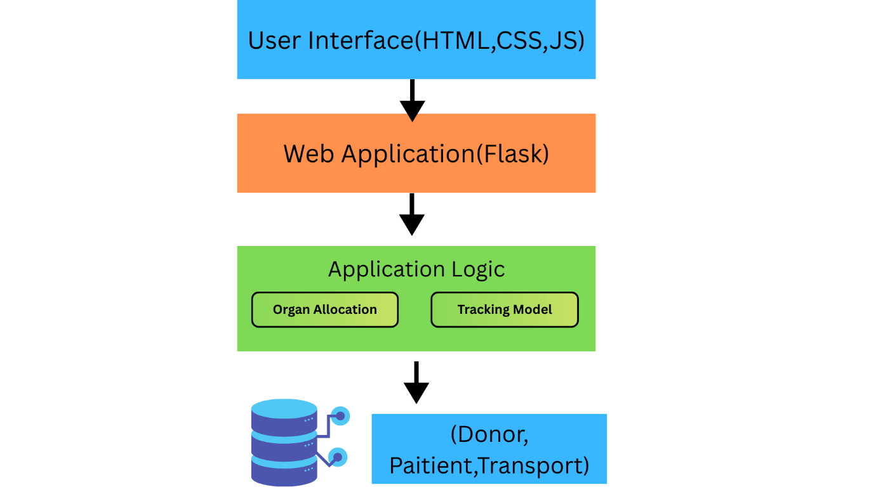
FIGURE 1: Architecture Diagram
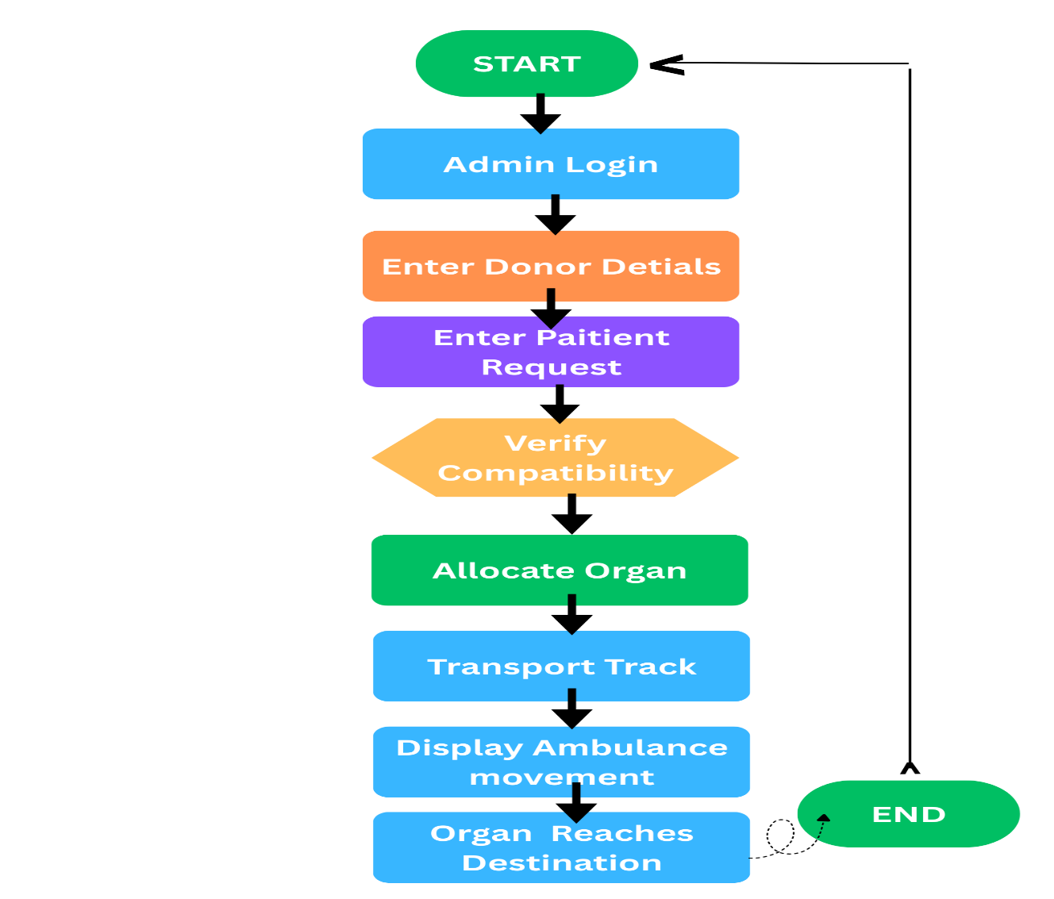
FIGURE 2: System Working flow
3.8 System Workflow Diagram
The workflow diagram also shows the operations sequence in the system. It starts with administrator log in and then donor registration and submission of patients request. Upon compatibility, the system assigns the organ and initiates the monitoring process of the transport. The ambulance movement is shown on the map up to the moment that the organ gets to the destination hospital, then the system changes the status of delivery. Secure Organ Transport Monitoring System has several functional modules that work in collaboration to facilitate the whole system functionality.
Administrator Module
The administrator module will provide the authorized users with the opportunity to manage the donor, patient requests and organ allocation procedure. The administrator has the ability to enter, edit and manipulate records that are stored in the system database.
Donor Management Module
The information about organ donors is stored in this module. The details will be stored in the form of name of the donor, blood group, type of organs and the location of hospital. The data is used during the allocation of organs.
Patient Request Module
The patient information is stored in the patient request module and also the organ requirements. This module will also help in identifying which patients would require to have undergone the process of transplantation, and also the module will help in matching the patients with the available donors.
Transport Monitoring Module
Only specific people need such module as the sales representative, marketers and receptionists: the Transport Viewing Module.
This module plays the role of keeping track of transportation of organs between hospitals. It demonstrates the route of the transportation vehicle and it is informed about the delivery of the organ after it has been delivered to the destination.
  - Database Design
A. Main Tables
All information that is necessary in the management of the organ transportation is stored in the system database.
B. Donor Table
Stores contain donor details such as donor ID, blood group, available organ and hospital information.
C. Patient Table
Stores data on patient such as patient ID, requested organ, blood group, and allocation status.
D. Transport Table
The transportation information of stores such as patient ID, tracking status, and delivery confirmation.
E. Database Operation
The database can be used to carry out operations to add the information about donors, change the status of the patient allocation, and save the transport records. The system replaces any information within the database whenever an organ is allocated or delivered.
To address such issues, the suggested system will present an organizing system of monitoring, covering donor registration, patient treatment, organ placement verification, and ambulance live tracking. The system will make sure that a single organ donor can only be given to one patient. The availability status is automatically updated in the database on the occurrence of which the allocation is already made and the transportation process has already started to avoid additional allocation.
Another feature of the system is the possibility of monitoring the route by means of a map interface where the movement of ambulance can be traced. The tracking process will be such that it should be initiated only once to achieve consistency of data and avoids duplication of transport records.
To overcome these challenges, the proposed system will offer a system of organization of monitoring, including the registration of donors, treatment of the patients, checking the location of the organs, and the live tracking of the ambulances. The system will ensure that one organ donor is allocated to one patient. Availability status is automatically changed in the database whenever the same has already been allocated and the transportation process is in progress to prevent further allocation.
3.10 Data Management Process
The proposed system includes the data management. This system is based on the relational database to store and manage information of donors, patients, and activities on transport.
The database is used to ensure that all the records are stored in an orderly way and can be accessed easily whenever they are needed. Whenever a new donor or a patient record is entered, the system will place the information into a suitable database table. In the organ allocation process, the system retrieval of the appropriate records is done to check their compatibility and change the status of the allocation. Effective data management enhances the reliability of the systems and is useful in achieving the information accuracy during the entire process of organ transportation.
CHAPTER 4
RESULTS AND DISCUSSION / ANALYSIS.
4.1 Implementation Results
It was successfully applied as a web-based system to monitor the secure movement of organs with the help of the database integrations. The system enables the administrators to control the donor data, requests of patients and transportation with the help of interactive web interface.
The system was installed and tested using sample donor and patient data to check the functionality of organ allocation and monitoring of their transportation during implementation. Information about the donor including donor name, blood group, organ type and hospital details can be added by the administrator. The system database also stores patient information such as patient name, organ required, and the location of the hospital.
After entering the donor and patient information, the system will do the compatibility check and allocate the organ to the correct patient. Once allocation is done, the status of the donors is automatically updated in the database to avoid duplication of allocations.
Another feature offered by the system is transport monitoring, which shows the ambulance route on a digital map. The ambulance animation is also a visual performance that shows the flow of the transport vehicle between the donor hospital and the recipient hospital.
Tracking restraint mechanism: A tracking restraint mechanism makes sure that the transport tracking process can only be initiated once in regard to a particular patient request. In case the administrator tries to track once more once the organ has already arrived at the destination, the system sends a message stating that the organ has already been received. This will eliminate duplication of tracking and have proper records of transport.
4.2 Functional Analysis
The system was evaluated in accordance with functionality of the key modules. All the modules have their individual roles that they play in the operation of the entire system. Secure Organ Transport Monitoring System was to be developed to enhance management and monitoring of transportation of organs between hospitals

Donor Management
Donor management module is a database that contains the donor details. The system is able to capture the donor information and avail the same information to facilitate a compatibility check in the process of allocating the organs.
Patient Request Management
The patient request module enables the administrator to put on record patients seeking to obtain organ transplants. The system contains patient information and retrieves it during search of compatible donors.
Organ Allocation
The allocation module confirms the match of the donor and the patient records depending on the type and availability of organ, etc. After the system has verified compatibility, it allocates the organ to the patient and puts the donor status in the database.
Transport Monitoring
The transport tracking system imitates the flow of the ambulance between the ambulance donor hospital and the recipient hospital. The visual aspect of this feature represents the transportation process and allows the administrators to track the delivery process.
Delivery Confirmation
Once the transportation process has been done, the system modifies the delivery status in the database. This makes sure that the organ has been delivered to the destination hospital.
This paper aims to evaluate the performance of the system designed to oversee and manage the hospital in question.
4.3 System Performance Evaluation
The purpose of this paper is to evaluate the performance of the system developed to monitor and manage the hospital in question. The system was measured according to response time, accuracy and reliability.
All the database operations including the insertion of donor and patient details were successfully done within a minimal response time. The process of data retrieval was also efficient and the system was able to check the availability and compatibility of donors rapidly.

The process concerning organ allocation showed proper matching of the records of the donors and the patients. The system also made sure that a donor organ would not be assigned more than once and this avoids the errors of duplication.
Transport monitoring feature functioned properly as it showed the route and reflected the delivery progress as well. The tracking limitation tool also prevented repeated tracking processes of a single patient request. On the whole, the system was reliable and recorded down the right data during the experiment.
The system adopted was tested on the basis of functionality, response time and stability of organ transport monitoring process. The patient request and the donor registration modules are able to store data in the database with a low response time. The organ allocation procedure is effective in ensuring the verification of availability of donors and duplication is avoided.
The ambulance tracking module is useful in showing the track path movement and updating the tracking position in the database. The system also makes sure that the tracking is initiated once a patient request is received and the tracking is not repeated.
Database functions of inserting, updating and retrieving records were performed effectively during testing. This would make the system keep accurate records on the donor allocation and delivery of organs. All in all, the system is reliable in its work with organ allocation and monitoring the transportation process.
4.4 Advantages of the Proposed System.
The suggested Secure Organ Transport Monitoring System possesses several advantages over the manual systems that are used in the management of organ transportation.
The most significant advantages of the system are increased transparency. The system maintains the correct database of the donor information, requests and organ allocation. This will reduce the possibility of mistakes and proper records of all the operations are recorded.
This is the other advantage, as there is more coordination of hospitals. The administrators can also get access to the information regarding the donors and patients immediately since the information is stored in a central database.
It is also a system that provides improved monitoring during the process of transportation of organs by displaying a graphical representation of the transport vehicle movements. It will help the administrators to keep track of the progress of the delivery process, and will ensure the organ is delivered to the destination in a safe way. Overall, the system simplifies the processes of organ transportation and increases the reliability of the same.
4.5 Discussion
The system developed offers a well-organized and clear methodology in handling the information in organ transportation. The system reduces the chance of discrepancies in data and errors in data entry since the records of the donors and the patients are stored in a central database. Transportation monitoring aspect promotes transparency because it enables the administrators to monitor the movement of the transport vehicle. This enhances coordination of hospitals in the delivery process of the organ. Even though the system has proven to be effectively functional, some more enhancements should also be made like the integration of real time GPS and automated notifications of the hospital as these would also make the system performance better. The outcomes of the implementation prove that the suggested system will be able to serve the purpose of managing and monitoring organ transportation activities.
4.6 Reliability of the System
The system was tested on its reliability based on the capability to support various operations like donor registration, entry of patient requests and allocation of organs. These operations were also tested and executed successfully by the system.
The database kept track of the records during the testing process and the status of donor availability and patient allocation was updated appropriately. This proves that the system is capable of effectively dealing with organ transportation information and keeping good records.
4.7 System Usability
The ease of use and simplicity of user interface were assessed as the usability of the system. The interface of the system was user-friendly, and the administrators easily added and handled the information of the donors and patients. The movement across the modules is easy and manual and allows the administrators to carry out functions like donor registration, entry of patient requests and tracking of transport smoothly. It is easy to use the interface design as it limits the possibilities of user errors and enhances the usability of the system.
CHAPTER 5
CONCLUSIONS AND FUTURE WORK SCOPE.
5.1 Conclusion
Secure Organ Transport Monitoring System was to be developed to enhance management and monitoring of transportation of organs between hospitals. It is a systematic system that is used to store information on donor and patients, assigning the organs and tracking the transportation process in a professional way. The integration of database management and web-based technologies as a part of the proposed system allows reducing the number of manual errors and enhancing the effectiveness of organ allocation and the monitoring of transportation. The introduction of the system shows that the information about the donors and request of a patient can be stored, retrieved, and processed with the help of a centralized database. The organ allocation module is used to make sure that the correct patient receives their organs according to the availability whereas the transport monitoring part gives the cloudy picture of the progress of the organ transport vehicle between the hospital where organ was donated and the recipient hospital. The records of every transaction are also kept in the system and this adds up to transparency and reliability in the process of organ transportation. In the course of testing, the system was able to perform registration of donors, request of patients, allocation of organs and tracking of the transportation process without errors. The findings indicate that the proposed system would be effective in assisting hospitals to control the organ transportation operations and keep correct records of the delivery process. All in all, the system created offers an easy, dependable, and effective way of tracking the activities of the organ transplantation and guaranteeing the delivery of the organs to the destination safely and effectively.
5.2 Scope for Future Work: To further enhance the system, it can be expanded in the future by incorporation of real-time GPS location to generate more precise results on the location of the organ carrying vehicle. Other characteristics like automatic notification of the hospital, mobile app support, and increase in security measures may be added to the system to improve its performance. It can also be expanded with the integration with national organ donation databases, which will allow the system to match the donors and patients in multiple hospitals faster. Such improvements would make the system more sophisticated and applicable to a large-scale healthcare setting. Other security control systems such as blockchain technology could also be incorporated in order to achieve integrity of data and discourage any unauthorized manipulation of the records of systems.
CHAPTER 6
APPENDIX -A
System Output Screens Introduction.
In the appendix section, a summary of the system interface and significant modules that were developed in the Secure Organ Transport Monitoring System is provided. These displays show how the system handles the information of donors, requests of patients, allocation of organs as well as transportation tracking using a Web-based system.
The interface system is planned to offer easy and friendly interface that is easy to use by the administrators in the management of efficient organ transport activities. Every module of the system has a certain purpose and serves in the functioning of the application as a whole.
A.1 Administrator user interface.
There is the administrator login that offers secure access to the system. Users are only allowed to log into the system and view the system dashboard. The login page will have valid credentials so that only the authorized personnel will be able to manipulate the donor and patient records.
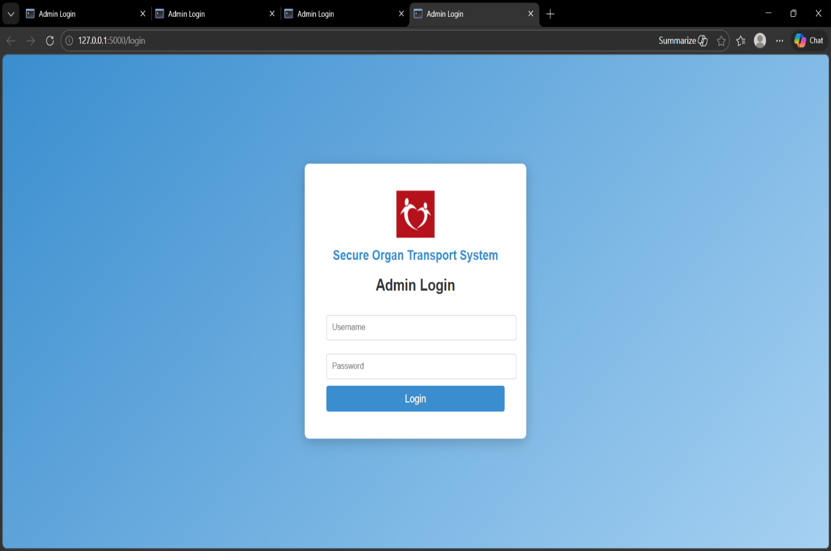
Figure 3: Login Interface of the Administrator.

A.2 Donor Registration Page
The donor registration page enables the administrator to key in the details of donors into the system database. The database stores information like the name of the donor, blood group, donor organ available and the hospital where the donor is based so that they can be referred to later.
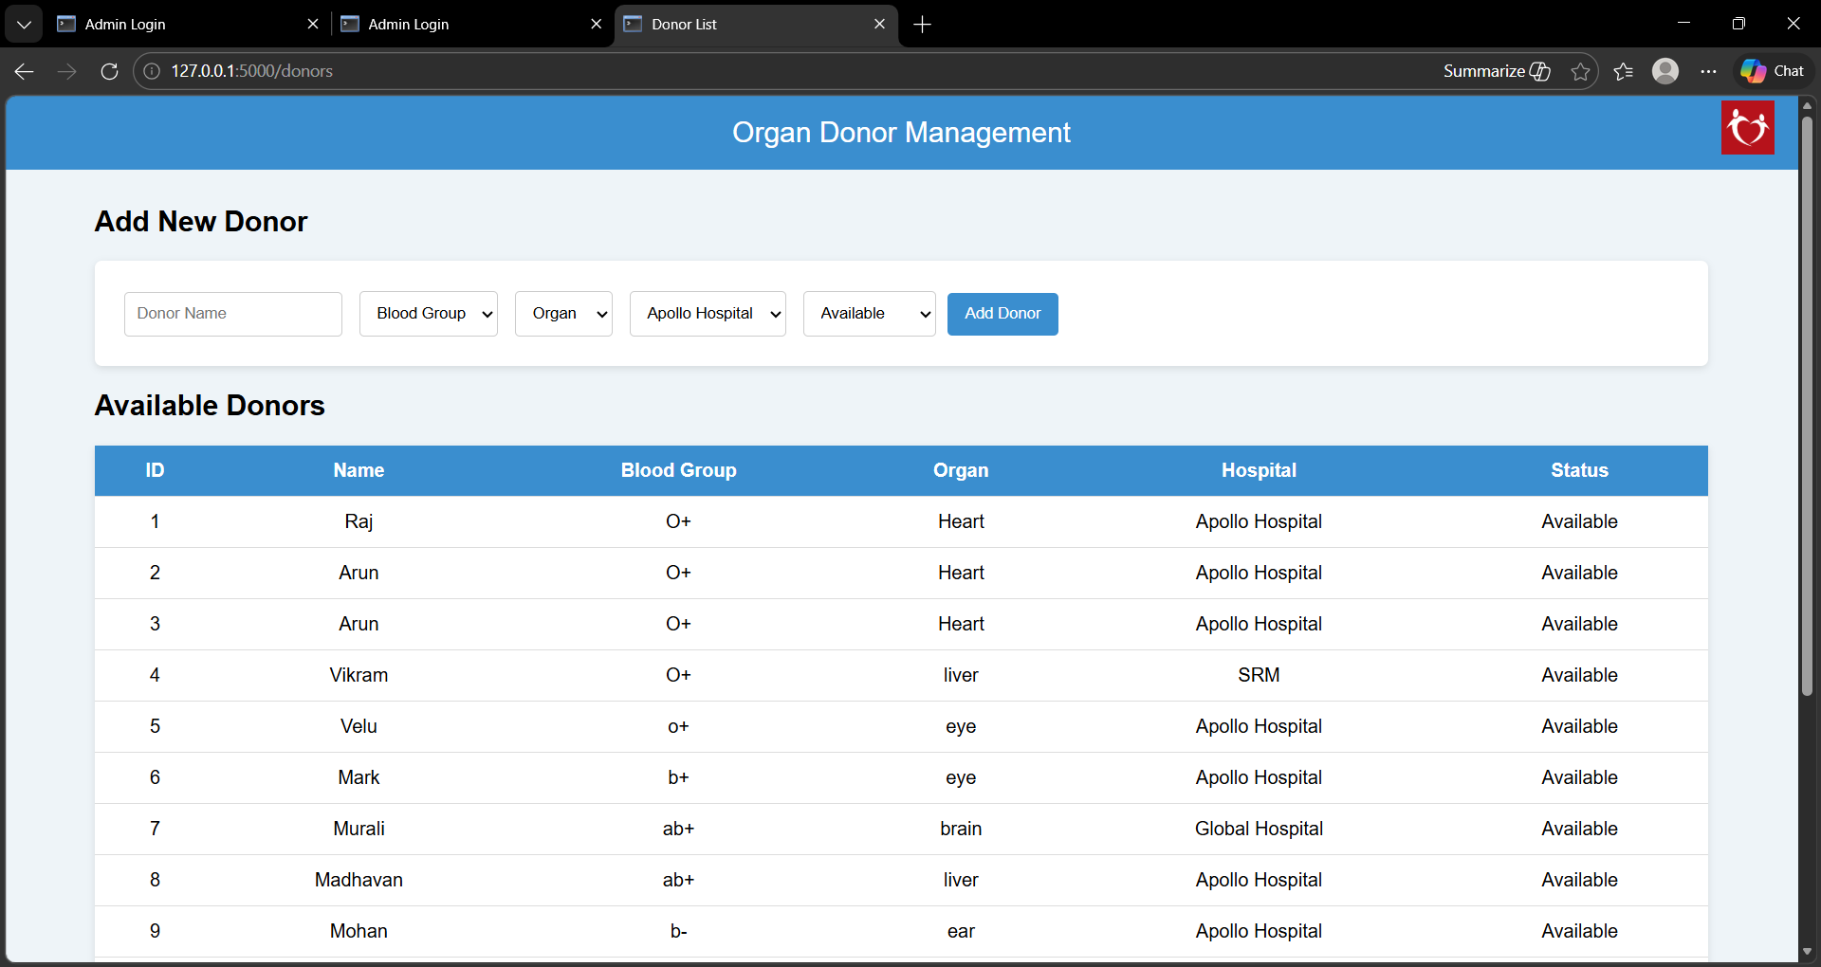

Figure 4: Interface of Donor Registration.
A.3 Patient Request Page
Patient request page gives the administrator the opportunity to enter patient information such as the name of the patient, the organ he or she needs, blood group, and hospital. Such information assists the system in identifying the patients in need of organ transplantation...The patient request module is where the information of the patients awaiting organ transplant is kept. The patient’s name, organ to be required and hospital location are some of the information that are recorded in the system.

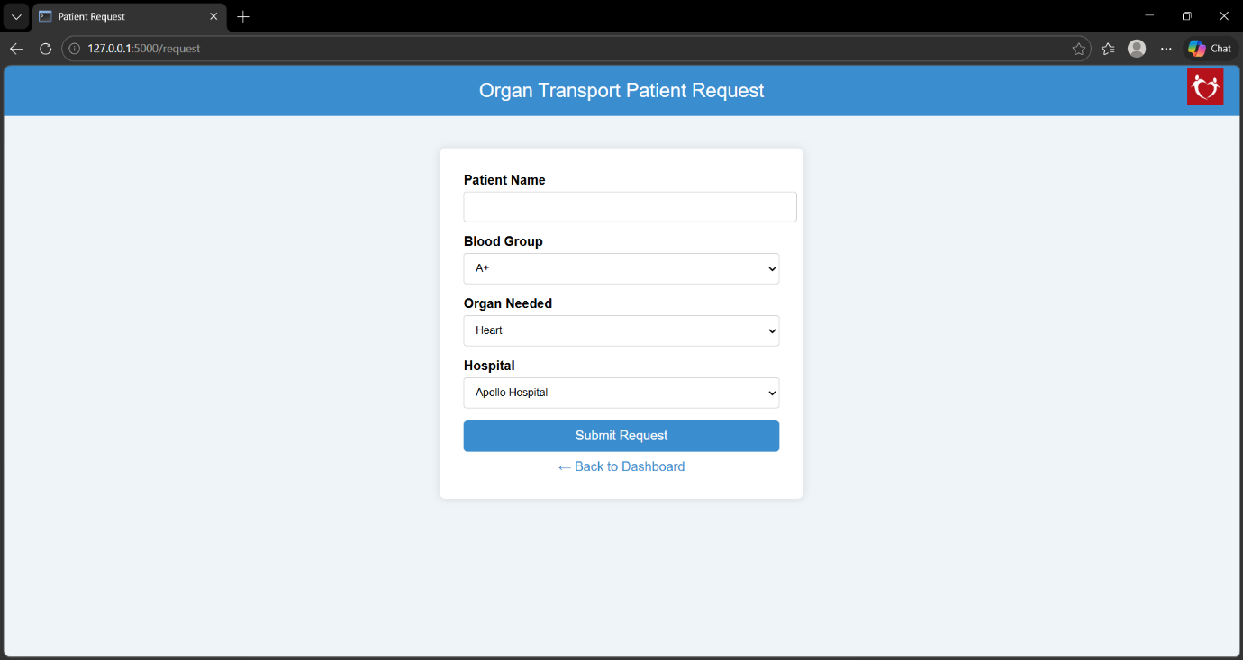
Figure 5: Interface of a patient request.

A.4 Organ Allocation Page
The compatibility check between the records of the donor and the patient is indicated on the organ allocation page. After compatibility, the system allocates the organ to the patient and the database is updated to indicate the allocation.
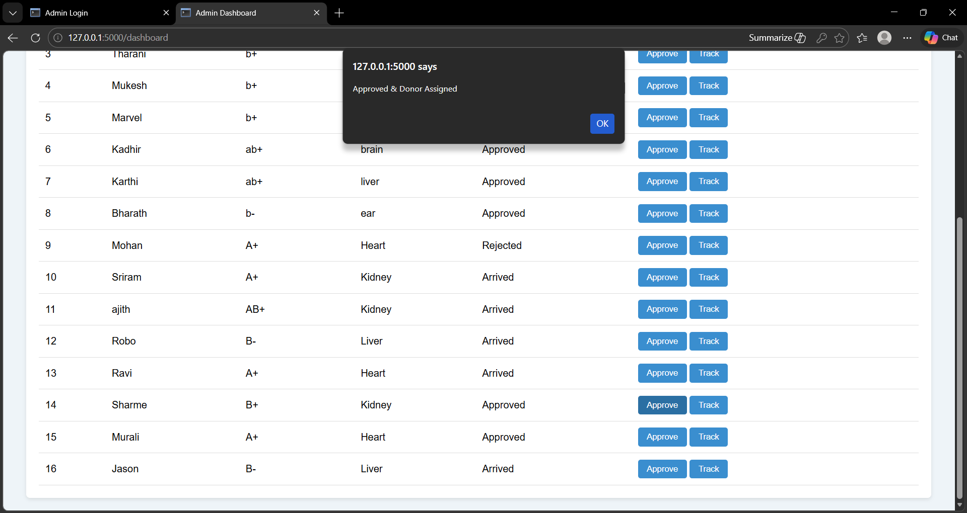
Figure 6: Organ Allocation Interface.
A.5 Transport Monitoring Interface
The transport tracking page shows the flow of the ambulance that is carrying the organ between the hospitals. The system has a visual network of the transport vehicle path to show the administrators a clear view of the progress of the delivery.
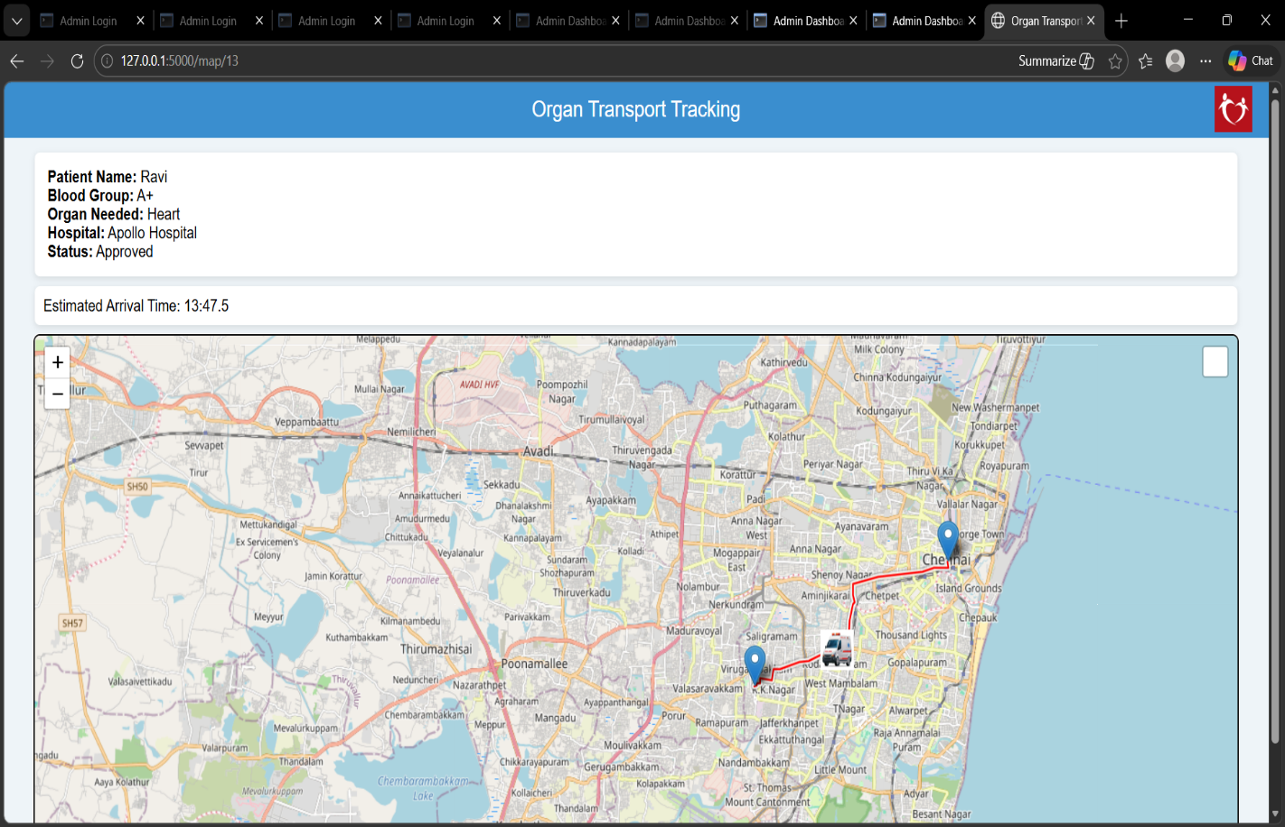

Figure 7: Organ Transport Interface.

A.6 Delivery Confirmation Page.
Once the transportation process has been made, the system will update the patient record to ensure that the delivery of the organs is successful. This page means that the organ has arrived at the destination hospital. After the transport vehicle has reached the destination hospital, the system fills in the patient record and presents the message of successful delivery of the organs. The outcomes of the system prove that the suggested solution could be efficient to control organ transportation processes and keep safe and reliable records. Limitations of the repeated tracking functions promote the credibility of the monitoring process by making sure that the recording of each transport event occurs only once.
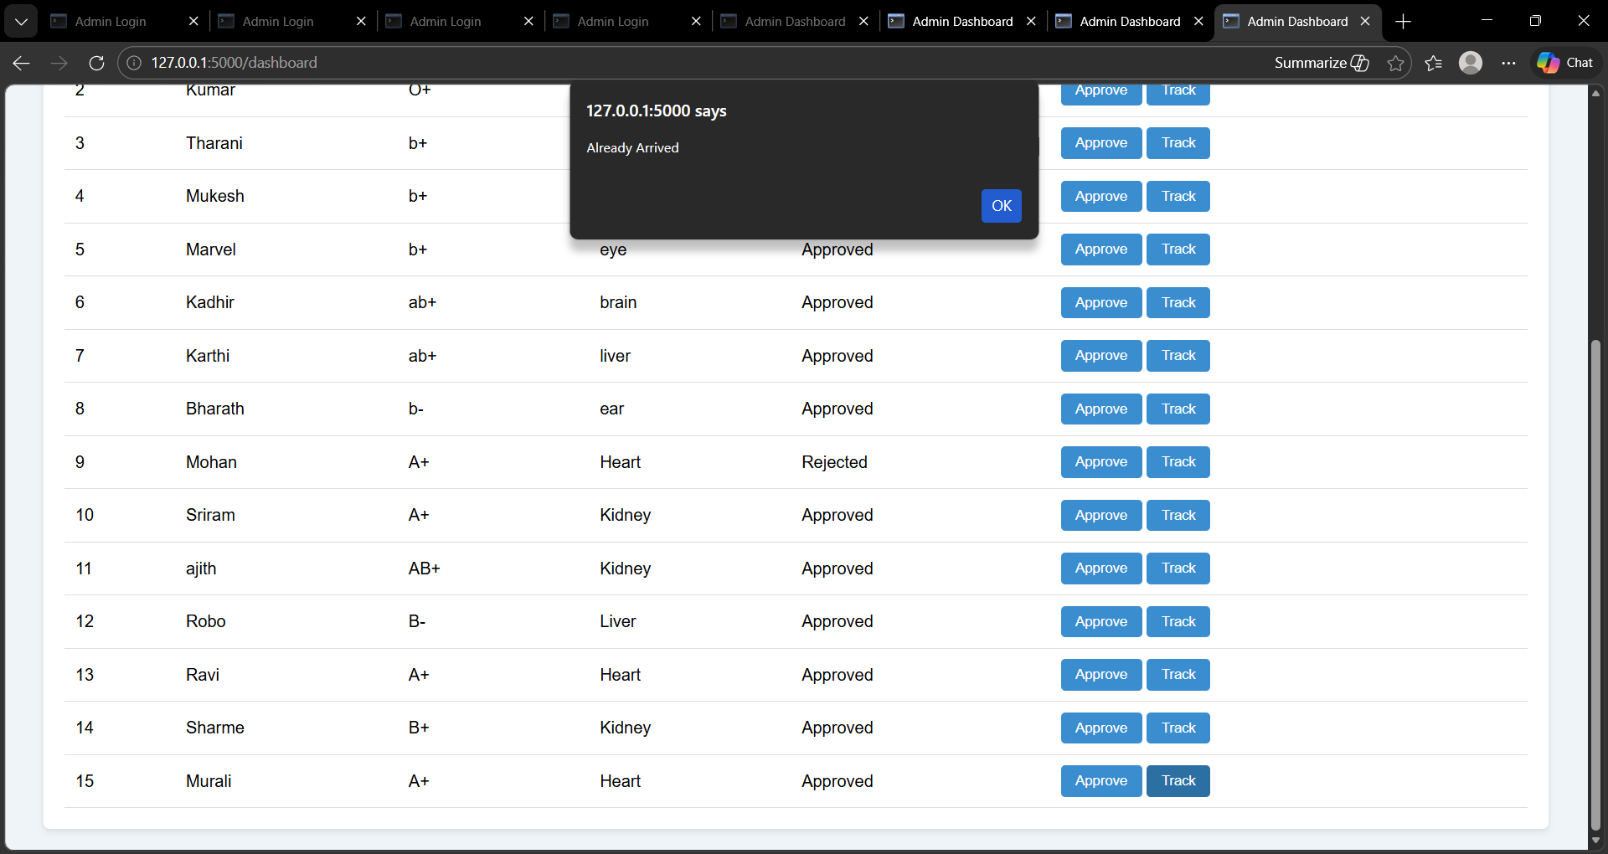
Figure 8: This is the Organ Delivery Confirmation Interface

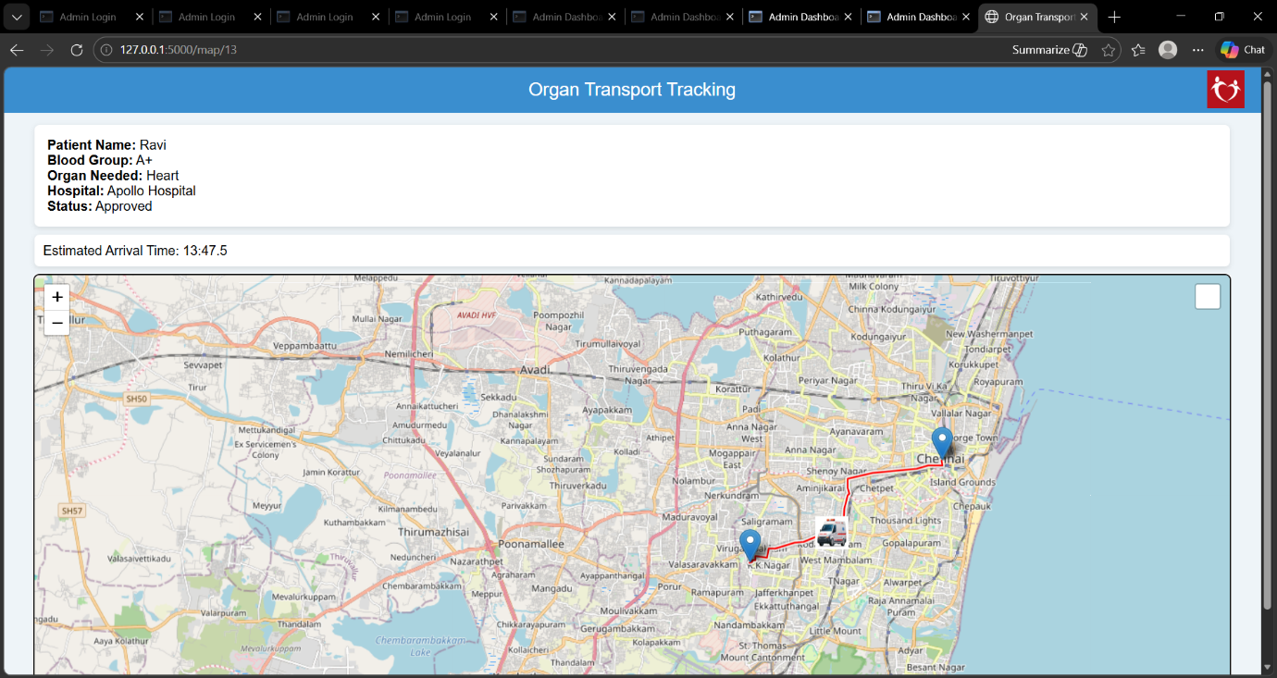

Figure 9: This is the Organ Delivery Confirmation Interface EAT Display

APPENDIX B
DESCRIPTION DATABASE TABLES DESCRIPTION.
The secure organ transportation monitoring system has been based on the relational database to store and manage the information data related to donors, patients and transportation tracking. The database is important in maintaining the appropriate records and adequate data management of records in the system. When assigning and tracking organs during transportation, the database model will be designed in such a way that it ensures the efficient storage, retrieval and updating of information in the database.
B.1 Donor Table
The donor table has the information of donors of organs. The details that have been contained in this table include donor identification number, donor name, type of organ, blood group and hospital location. The knowledge regarding the donors is used during the organ transplanting process to identify the appropriate donors to transplant the patients requiring the surgery.
All the donor details are appropriately identified giving them a donor ID so that they are not confused in the database. After an organ has been allocated to a patient, the system would revise the donor availability status, to avoid a case of allocating one organ to the same patient twice or more.

Figure 11: Donor Table using SQL server

B.2 Patient Table
It is a patient table in which the data of the patients who have been waiting to receive organ transplant are stored. The table will include patients ID, patient name, organ needed, blood group and the hospital.
It is also applied in the matching of the patients to the right donors during the process of the organ allocation. Once a patient has been assigned a donor organ the record of a patient will be updated to indicate the allocation and delivery status.

Figure 12 : Patient Table SQL server
B.3 Transport Tracking Table
Transport tracking table is a table that stores the associated data of transportation of organs among hospitals. This table records the commencement of tracking and whether the destination hospital organ has been reached or not.
The tracking status ensures that the process of tracking the transport is initiated on a single occasion in relation to each patient request. The database of the delivery status is updated as soon as the transport vehicle is delivered to the destination hospital with the help of the system.
Example Table Structure
Name of field Type of data Comment.
TrackingID INT Uniqueness tracking identifier.
PatientID INT Identified patient ID.
TrackingStarted INT The value indicates whether tracking has been initiated or not.
Status of organ delivery VARCHAR Status of organ delivery
B.4 Database Operations
The database performs a few operations in order to enable the system operation. These functions include registering the donors record, keeping the requests of the patients and the allocation of the organs and the follow-up of the information regarding the transport.
APPENDIX C
PRESENTATION CERTIFICATE AT THE CONFERENCE.
The following appendix shows the certificate obtained when presenting the research work in the field of the proposed system. The article was published in the International Conference on Recent Trends in Mathematics and Computer Science (ICRTMCS -2025) which was hosted by Auxilium College of Arts and Science to women. The conference gave an academic opportunity to introduce the research idea and communicate the suggested method of making the organ transportation systems more transparent and monitored. The certificate recognizes registration and presentation of the research work in the conference. The certificate of presentation obtained due to the research paper is presented in the following figure.
.
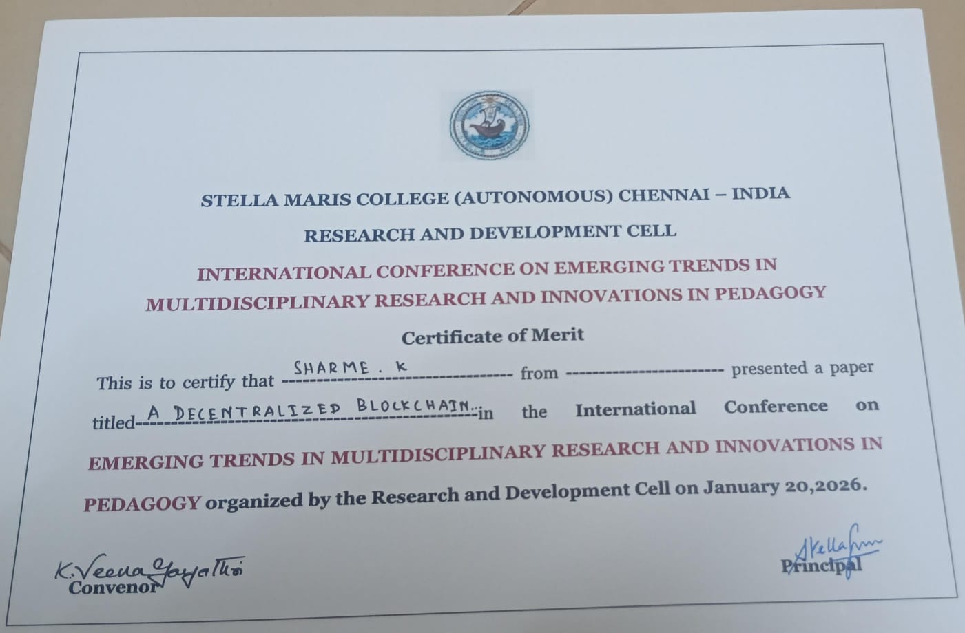
REFERENCES
- Zhang, D., et al. “Blockchain-Based Multi-Access Edge Computing for Vehicular Networks.” IEEE.
- Sun, G., et al. “Blockchain Enhanced Energy Sharing in Internet of Electric Vehicles.” IEEE.
- Shrestha, R., et al. “A New Type of Blockchain for Secure Message Exchange in VANET.” IEEE.
- Wang, L., and Y. Wang. “Supply Chain Financial Service Management System Based on Blockchain.” IEEE.
- Gao, Z., and W. Yan. “Real-Time Data Processing Framework for Blockchain and Edge Computing.” IEEE.
- Zhang, R., and M. Yu. “Secure Vehicle Communication Using Blockchain.” IEEE.
- Wang, L., and X. Li. “Blockchain-Enabled Secure Logistics System.” IEEE.
- Sharma, S. K., and R. Kumar. “Blockchain-Based Patient Data Management in Healthcare.” IEEE.
- Li, F., and H. Zhao. “Edge Computing for Smart City Applications.” IEEE.
- Singh, A., and M. Gupta. “Blockchain-Based Secure Transaction System.” IEEE.
- Chen, M., and Y. Zhang. “Blockchain in Healthcare: Security and Privacy Issues.” IEEE.
- Patel, H., and S. Rathi. “Blockchain for Logistics and Emergency Management.” IEEE.
- Lee, K., and J. Kim. “Blockchain-Enabled Real-Time Vehicle Tracking System.” IEEE.
- Zhao, P., and Y. Lin. “Secure Record Keeping in Transportation Networks.” IEEE.
- Kumar, D., and S. Singh. “Web-Based Logistics Management Using Blockchain.” IEEE.
- Androulaki, E., et al. “Hyperledger Fabric: A Distributed Operating System for Permissioned Blockchains.”
- Dorri, A., et al. “Blockchain for IoT Security and Privacy.” IEEE.
- Christidis, K., and M. Devetsikiotis. “Blockchains and Smart Contracts for the Internet of Things.” IEEE.
- Zheng, Z., et al. “An Overview of Blockchain Technology.” IEEE.
- Reyna, A., et al. “On Blockchain and Its Integration with IoT.” IEEE.
- Xu, X., et al. “A Taxonomy of Blockchain-Based Systems for Architecture Design.” IEEE.
- Nakamoto, S. “Bitcoin: A Peer-to-Peer Electronic Cash System.”
- Casino, F., et al. “A Systematic Literature Review of Blockchain-Based Applications.”
- Saberi, S., et al. “Blockchain Technology and Its Relationships to Sustainable Supply Chain Management.”
- Swan, M. Blockchain: Blueprint for a New Economy.

